SEQUENCE DIAGRAMS

• ACCESS AND SECURITY

1. The manager initiates a request to view the analytics page.

2. The analytics page sends a request to the authentication server to authenticate the manager.

3. The authentication server prompts the manager for their username and password.

4. The manager submits their username and password to the authentication server.

5. The authentication server verifies the submitted credentials.

6. If required, the authentication server prompts the manager for multi-factor authentication.

7. The manager confirms the multi-factor authentication.

8. The authentication server verifies the multi-factor authentication.

9. Once authentication and authorization are successful, the authentication server notifies the analytics page.

10. The analytics page grants access to the manager and displays the analytics.

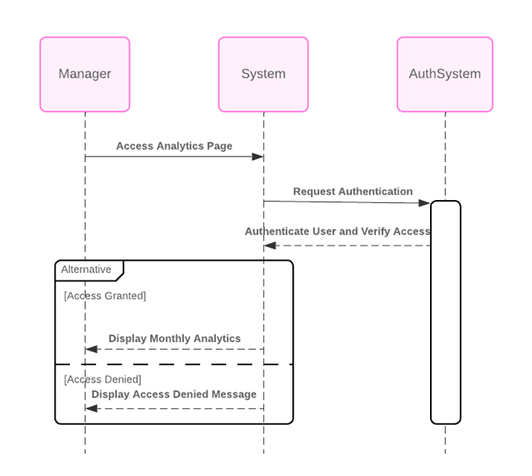

• Filtering and Sorting Options

1. he manager initiates a request to view the dashboard with filtering and sorting options.

2. The dashboard system sends a request to the backend system to retrieve the monthly analytics data.

3. The backend system responds by sending the monthly analytics data to the dashboard system.

4. The dashboard system applies the specified filtering and sorting options to the received data.

5. Finally, the dashboard system sends the dashboard with filtered and sorted data back to the manager for viewing

